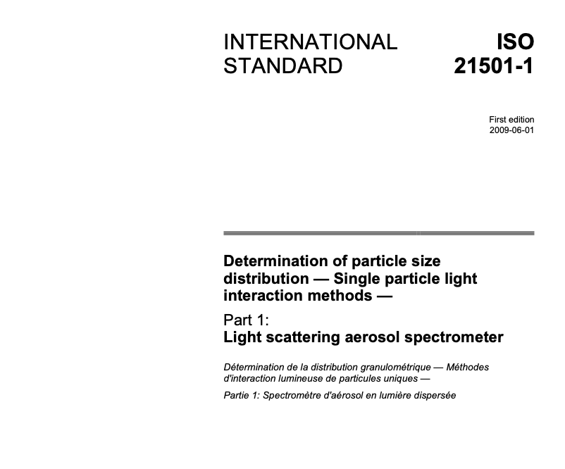

Introduction
Monitoring particle size distributions and particle number concentrations is required in various fields, e.g. in filter manufacturing, in the electronic industry, in the pharmaceutical industry, in the chemical industry, in the manufacture of precision machines and in medical operations. The aerosol spectrometer is a useful instrument for the determination of the size distribution and number concentration of particles suspended in a gas. The purpose of this part of ISO 21501 is to provide the calibration procedure and the validation method for aerosol spectrometers, so as to improve the accuracy of the measurement result by aerosol spectrometers in general, and to minimize the difference in the results measured by different instruments.

Determination of particle size distribution - Single particle light interaction methods -
Part 1:
Light scattering aerosol spectrometer
1 Scope
This part of ISO 21501 specifies characteristics of a light scattering aerosol spectrometer (LSAS) which is used for measuring the size, number concentration and number/size distribution of particles suspended in a gas. The light scattering technique described in this part of ISO 21501 is based upon single particle measurements. The size range of particles measured by this method is between approximately 0,06 μm to 45 μm in diameter.
Instruments that conform to this part pf ISO 21501 are used for the determination of the particle size distribution and particle number concentration at relatively high concentrations of up to 10¹¹particles/m³.
Application fields include:
- characterization of metered dose inhalers (MDI), dry powder inhalers (DPI) and nebulizers in pharmacy;
- production control of active agents;
- cut-off determination: impactors, cyclones and impingers;
- atmospheric aerosols: bio-aerosols, stables/composting facilities, nebulized droplets, measurements in street tunnels;
- fractional separation efficiency determination of filters.
For the above-mentioned applications, aerosol spectrometers should determine the particle size distribution, particle number concentration, size resolution and sizing accuracy as accurately as possible. These aerosol spectrometers are not suitable for the classification of clean rooms.
2 Terms and definitions
For the purposes of this document, the following terms and definitions apply.
2.1 particle
discrete element of the material regardless of size
[ISO 2395:1990]
2.2 aerosol
suspension in a gaseous medium of solid particles, liquid particles or solid and liquid particles having a negligible falling velocity
[ISO 4225:1994]
NOTE In general, one divides the atmospheric aerosol into three size categories: the superfine range x < 0,1 μm, the fine range 0,1 μm < x < 1 μm and the coarse range x > 1 μm, where x is the particle diameter.

2.3 particle size
size of a sphere having the same physical properties in the method of analysis as the particle being described
NOTE 1 See also equivalent particle diameter (2.4).
NOTE 2 There is no single definition of particle size. Different methods of analysis are based on the measurement of different physical properties. The physical property to which the equivalent diameter refers shall be indicated using a suitable subscript or reference to the documentary measurement standard according to which the particle size was measured.
In ISO 9276 the symbol x is used to denote the particle size or the diameter of a sphere. However, it is recognized there that the symbol d is also widely used to designate these values. Therefore the symbol x may be replaced by d where it appears.
2.4 equivalent particle diameter
diameter of the sphere with defined characteristics which behaves under defined conditions in exactly the same way as the particle being described
2.5 light scattering equivalent particle diameter
xsca
equivalent diameter of a homogeneous sphere of a reference substance (e.g. latex) which scatters defined incident light with the same radiation efficiency into a defined solid angle element
2.6 number concentration density distribution
density (frequency) distribution of the particle number concentration represented as a function of the particle size
2.7 particle concentration
indication of, e.g. particle numbers, particle mass, particle surface related to the unit volume of the carrier gas
NOTE For the exact concentration indication, information on the gaseous condition (temperature and pressure) or the reference to a standard volume indication is necessary.
2.8 coincidence error
probability of the presence of more than one particle inside the sensing zone simultaneously
NOTE Coincidence error is related to particle number concentration and size of sensing zone.
2.9 counting efficiency
relation of the concentration determined from the counting rate of the measuring instrument and the real concentration of the aerosol at the inlet of the instrument
2.10 border zone error
particle sizing error that occurs when particles pass through the optical border of the sensing zone
3 Requirements
3.1 Size range
The measuring size range is defined by the lower and upper size limit of quantification.
3.2 Counting efficiency
3.2.1 General
The counting efficiency is the relation of the particle number concentration CN,measured — determined from the counting rate of a device and corrected for possible coincidence errors — to the real particle number concentration CN,actual of the aerosol at the inlet of the device. The counting efficiency [η(x)] is a function of the particle size and is expressed as the ratio:
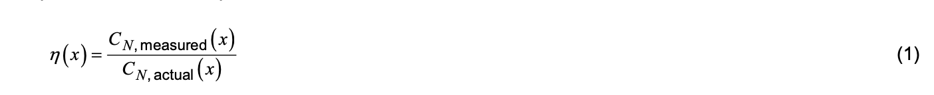
The counting efficiency is also a function of signal processing, the homogeneous illumination of the measuring volume and the extent to which the particles enter the measuring volume and flow rate.
Figure 1 shows a graphical representation of counting efficiency. In an ideal case, the counting efficiency in the middle of the measuring range — as represented here — has the value one. If an experimental examination results in a value deviating from one, then this is to be accounted for as a correction to the measurement result. Usually, one defines the lower and/or upper size limit of the measuring range for the particle size with the particle diameters for which the counting efficiency shows the value 0,5.
For a proper evaluation of a measuring instrument, it is useful to determine the complete counting efficiency curve, or to indicate the particle diameters corresponding to values of the counting efficiency (e.g. at 0,1 and 0,9) besides those corresponding to a counting efficiency value of 0,5. The counting efficiency can be determined according to 4.5.
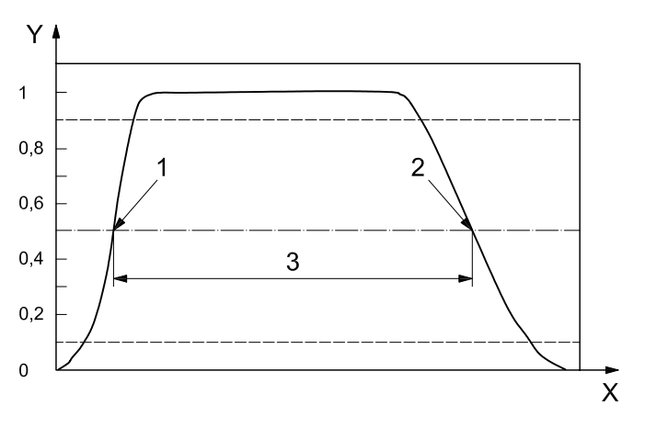
Key
X particle size
Y counting efficiency η (x)
1 lower size limit
2 upper size limit
3 size range
Figure 1 — Graphical representation of the counting efficiency [5]
3.2.2 Lower size limit
The lower size limit for the particle size is defined by convention to be the smallest diameter with which the counting efficiency shall be 0,5 ± 0,15 (50 % ± 15 %; lower size limit of the measuring range).
3.2.3 Upper size limit
The upper size limit for the particle size is defined by convention to be the largest diameter with which the counting efficiency shall be 0,5 ± 0,15 (50 % ± 15 %; upper size limit of measuring range). This is of particular interest if the aerosol inlet is situated horizontally in the LSAS, as particle losses can occur in the LSAS through impact and sedimentation.
3.3 Size resolution
The size resolution indicates which neighbouring particle sizes a particle measuring instrument can still differentiate between and record separately. Aerosol spectrometers should determine the particle size distribution and the particle number concentration as accurately as possible with high size resolution and good sizing accuracy. The size resolution depends on particle size.
Almost all measuring instruments determine the particle number concentration in a limited number of size classes which are firmly specified by the instrument design (e.g. instrument geometry, evaluation electronics, evaluation software). In practical operation, the size resolution of an LSAS cannot be better than the width of its size classes.
The size resolution can be determined according to 4.4.
3.4 Sizing accuracy
The sizing accuracy depends on the particle size. Therefore, the sizing accuracy can be evaluated for any particle size as follow
where
§(x) is the ratio of particle size difference, in %;
xr is the particle size of the certified reference material, in μm;
xs is the particle size indicated by the LSAS, in μm.
The sizing accuracy of an LSAS describes the difference between the actual calibration particle size and the particle size indicated by the instrument. The correlation between the particle size and size class stated by the manufacturer (channel number) is normally based upon a calibration of the instrument with a known test aerosol [mostly polymer latex (PL) particles]. Refer to Annex E.

3.5 Sampling flow rate
The sampling flow rate is the volumetric flow rate through the LSAS. Any error in the volume flow will affect the reported particle number concentration with a proportional relationship. The error in the sampling flow rate shall be within 5 %. Typical sampling flow rate is about 0,5 l/min to 5 l/min.
3.6 Effective detection flow rate
The effective detection flow rate is the volumetric flow rate through the optically and/or aerodynamically limited sensing zone. For particle number concentration measurements, the effective detection flow rate shall be evaluated. If the geometrical dimensions of the measuring volume are exactly known, the effective detection flow rate can be determined by measuring the transit time of the particles through the measuring volume. Otherwise, the effective detection flow rate has to be determined by a calibration experiment according to 4.2.
3.7 Maximum particle number concentration
The LSAS must be able to measure in high particle number concentrations up to 1011 particles/m3 and the maximum particle number concentration shall be specified by the manufacturer. According to 4.3, the coincidence loss at the maximum particle number concentration of an LSAS shall be equal to or less than 10 %.
4 Test method
4.1 Size calibration
The light scattered by the individual particles is detected and transformed into a voltage pulse. These pulses are classified according to their height in a multi-channel analyser (MCA). The result is a count rate histogram. This histogram is transferred into a particle size distribution by applying the calibration curve. This calibration curve, which is instrument specific, shall be determined either experimentally or theoretically. Normally, aerosol spectrometers are calibrated with monodisperse test aerosols of known (traceable) size and refractive index.
For the production of monodisperse test aerosols, several generation principles can be used. The size distribution of test aerosols with small variances are obtained if aqueous suspensions of PL particles are nebulized, dried and drawn through the instrument. Dry powder monodisperse PL particles are also useful for calibration.
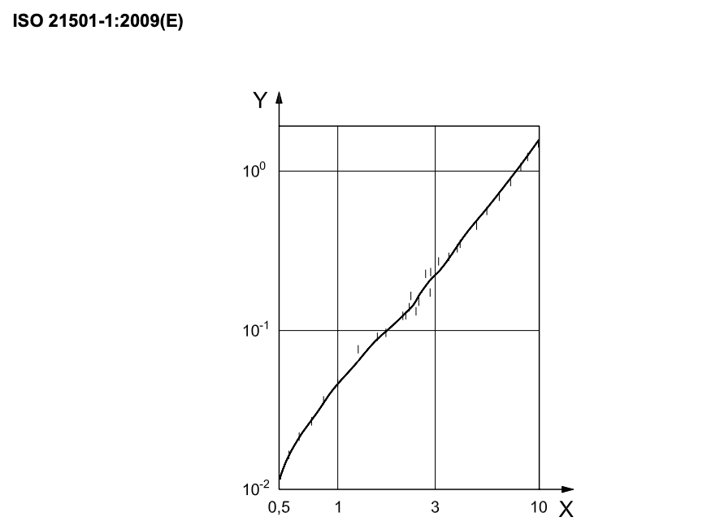
Figure 2 — Comparison of a theoretical calibration curve (line) and experimental data with monodisperse aerosol particles (vertical bars) [14]
Other techniques of providing narrow distributed aerosols are the vibrating-orifice generator or passing a polydisperse aerosol through a differential mobility analyser, which extracts particles within a narrow size range according to their electrical mobility.
4.2 Effective detection flow rate
The effective detection flow rate is obtained by relating the instrument particle count rate to a reference particle number concentration measurement using an instrument with a higher particle number concentration range than the instrument to be calibrated and that is traceable to internationally accepted standards.
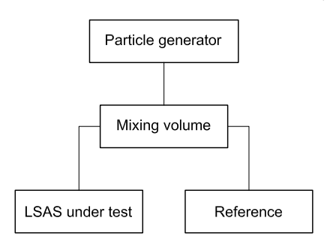
Figure 3 — Example for effective detection flow rate and counting efficiency test set-up
The effective detection flow rate is as follows.
where
qE is the effective detection flow rate, in volume per time;
N is the measured particle count rate by LSAS, in number per time;
CN,ref is the measured particle number concentration by reference instruments, in number per volume.
Effective detection flow rate calibration is necessary for counting efficiency evaluation. If the effective flow rate is unknown, the effective detection flow rate calibration shall be performed with particle sizes much smaller than the dimensions of the optical sensing zone, because larger particles effectively increase the resulting measuring volume. However, the particle size must be such that both the LSAS under test and the reference device have a counting efficiency close to 100 %.
4.3 Maximum particle number concentration
The maximum particle number concentration of an LSAS is determined by the coincidence loss, which is normally limited to 10 %. The coincidence loss is determined by the sampling flow rate, the time required for particles to pass through the sensing zone and the electrical signal processing time. These values are determined by the design of the LSAS. Calculation of coincidence loss is as follows:
where
L: is the coincidence loss, in %;
qE: is the effective detection flow rate, in m3/s;
t: is the time of passing through the effective sensing region plus electrical processing time, in s;
CN, max: is the maximum particle number concentration, in particles per m³.
There are several practical ways to ensure sufficiently low coincidence loss.
⎯ A defined and reproducible concentration change of the same aerosol can be performed. If the number concentration measured by the LSAS shows an equivalent change according to the defined conditions, both concentrations are below the maximum particle number concentration.
⎯ A reference instrument may be used to measure the reference concentration CN, ref. In this case, the particle size must be chosen such that the counting efficiency of both the LSAS and the reference instrument is close to 100 %. The number concentration range of the reference instrument must be greater than the maximum particle number concentration of the LSAS. As long as CN, LSAS/CN, ref is greater than 0,9, the number concentration is below the maximum particle number concentration of the LSAS.
In both cases, increasing the particle number concentration until a coincidence loss of 10 % is found will determine the maximum particle number concentration of the LSAS.
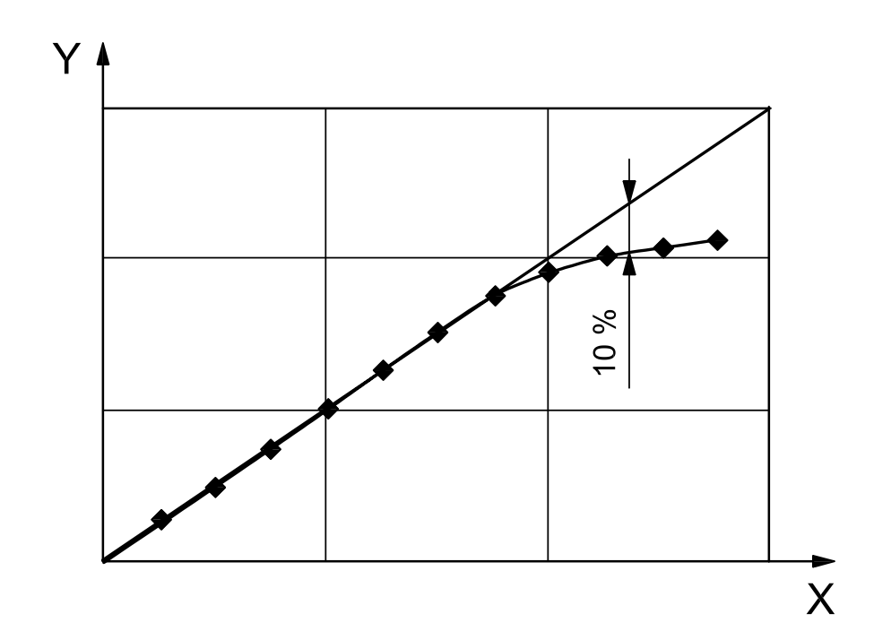Key
X: particle number concentration from defined concentration changes or CN, ref
Y: LSAS particle number concentration
Figure 4 - Example for a concentration comparison measurement to determine the coincidence loss and the maximum particle number concentration
4.4 Size resolution
The size resolution depends on the particle size. It can be determined by using monodisperse test aerosols with known geometric standard deviation ( σ PSL ). Determine the median MCA channel (Ch2 in Figure 5). The lower channel (Ch1) and upper channel (Ch3) are selected so that the relative counts are 61 % ± 10 % of the median channel. Using the calibration curve, determine the particle sizes corresponding to Ch1 and Ch3. Calculate the absolute value of the differences in particle sizes between the PL particle size and the particle sizes corresponding to Ch1 and Ch3. The larger difference in particle size is the observed standard deviation σ. Calculate the percentage of size resolution of the LSAS using Equation (5). (For further information, refer to Annex E.)
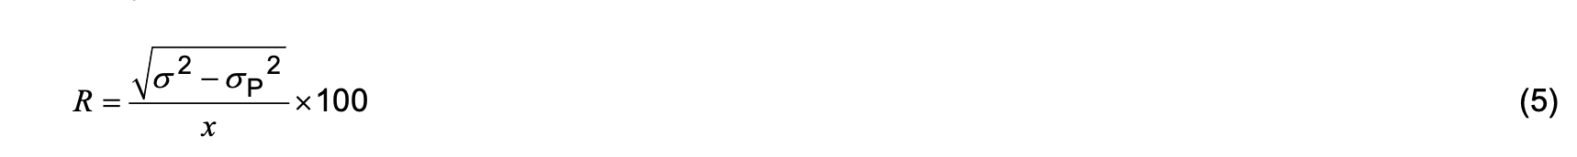
where
R: is the size resolution, in %;
σ: is the observed standard deviation of the LSAS, in μm;
σP: is the standard deviation of the particle size of the calibration particles, as reported by the reference material producer, in μm;
X: is the particle size of the calibration particle, in μm.
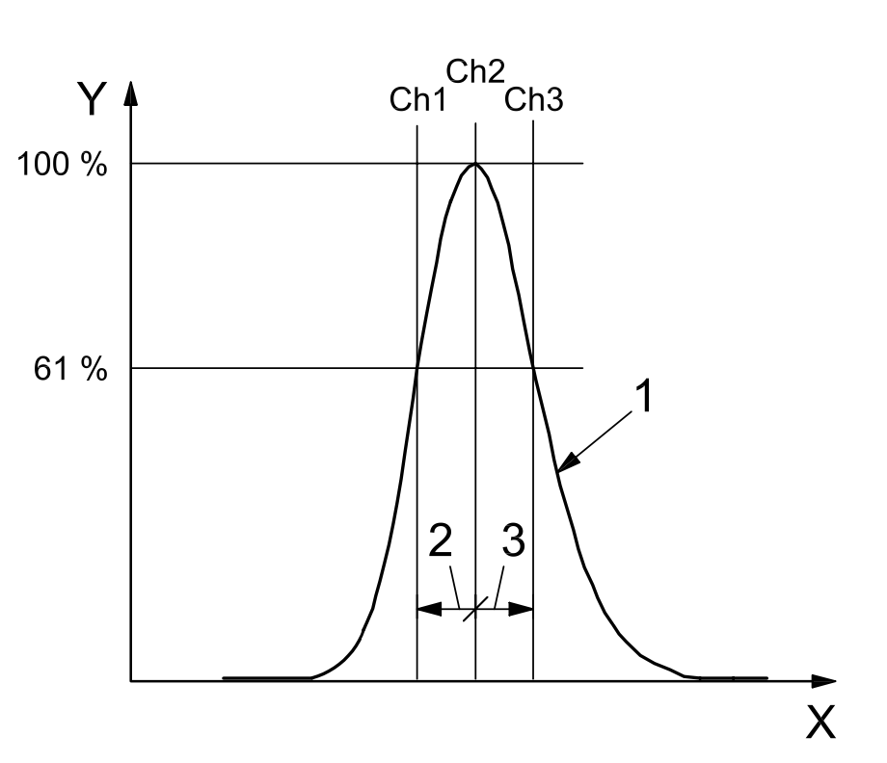Key
X: MCA channel
Y: relative count
- count rate distribution
- lower side resolution
- upper side resolution
Figure 5 — Size resolution
4.5 Counting efficiency
Counting efficiency can be experimentally determined by using the measuring set-up shown in 4.2. For the test of the counting efficiency according to 3.2, it is assumed that CN, actual = CN, ref.
It must be verified that
a) the LSAS under test and the reference counting device are below the 10 % coincidence limit,
b) the effective detection flow rate of the LSAS is correct,
c) the LSAS under test and the reference counter are calibrated correctly concerning particle size, the optics is not polluted and the electronics is adjusted correctly.
If Y > 1 in Figure 1, then CN, ref ≠ CN, actual or a), b) and c) are not adhered to. If Y = 1 in Figure 1, then the LSAS under test has 100 % counting efficiency.
If Y < 1 in Figure 1, then this is due to the sensitivity of the sensor (point 1 in Figure 1; see also point B in Figure 6) or to transport losses (point 2 of Figure 1).
If Y decreases with increasing CN, ref, then this is due to coincidence losses (see point A in Figure 6).
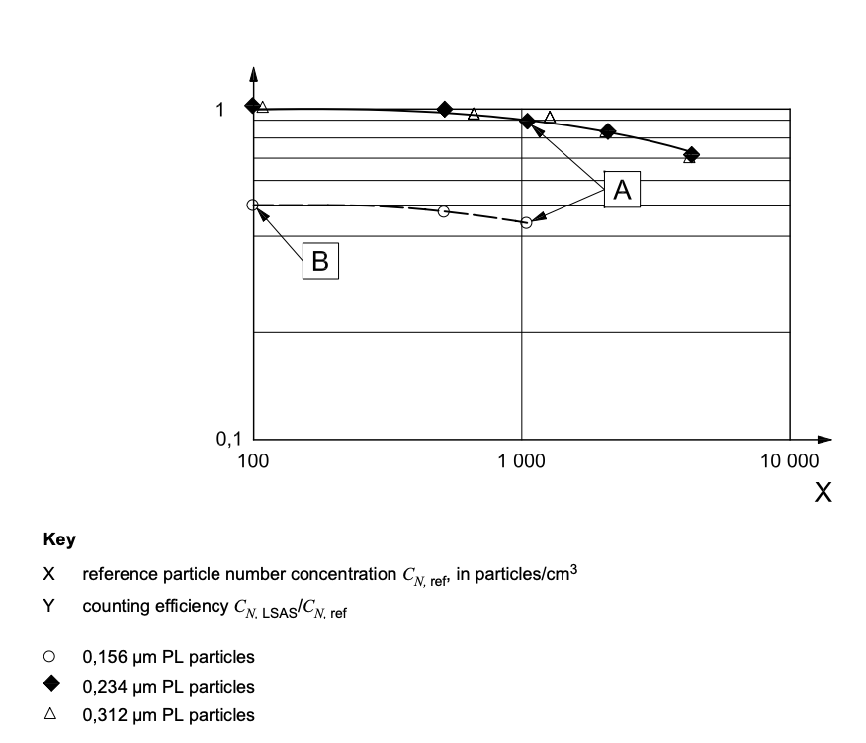Figure 6 — Counting efficiency is affected by coincidence A, incorrect flow rate (4.2) and decreasing sensitivity B of the instrument

Annex A
(informative)
Principle of the instruments
A.1 Light scattering A.1.1 General
The measuring method of an LSAS is based on the Lorentz-Mie theory. The particle characteristic, the diameter, is determined for individual particles which are assumed to be spherical, and the number of measured particles is registered at the same time.
If light with the wavelength λ meets a spherical particle with a diameter d and a refractive index n, then the light is scattered in different directions (Figure A.1). The scattering of light at the particle is caused by diffraction, refraction and reflection. The polarization plane of the incident light wave is also affected.
The intensity Ι of the light scattered from the single particles depends on the incident light intensity Ι0, the polarization angle Φ, the detection angle of the scattered light Θ, the refractive index n, the light wavelength λ and the particle diameter d.
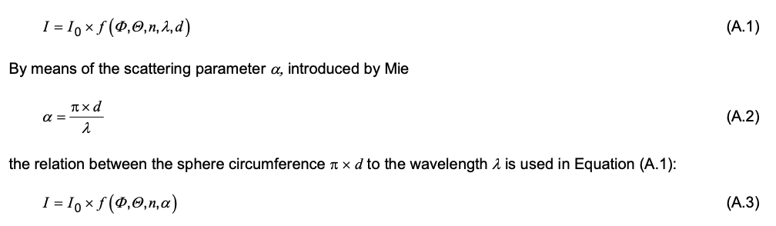
With regard to the particle-size-depending scattering power, three ranges can be distinguished in terms of the scattering parameter α (see Figure A.2).
a) Rayleigh range: α << 1; here the scattering power rises with the sixth power of the particle diameter, see References [6] and [17]. The scattered light will be proportional to d⁶ /λ⁴. This means if in the Rayleigh range one wants to be able to measure a particle half as large as before (lower size limit), then doubling the supplied quantity of light is not enough. The required quantity of light must be possibly 64-times stronger than for a particle twice as large.
b) Mie range: 0,1 u α u 10; here the relation between the scattered light intensity and the particle size is not monotonic for certain optical configurations (Figure A.2).
c) Fraunhofer range: α >> 1; here a quadratic relation between the scattering power and particle diameter is valid.
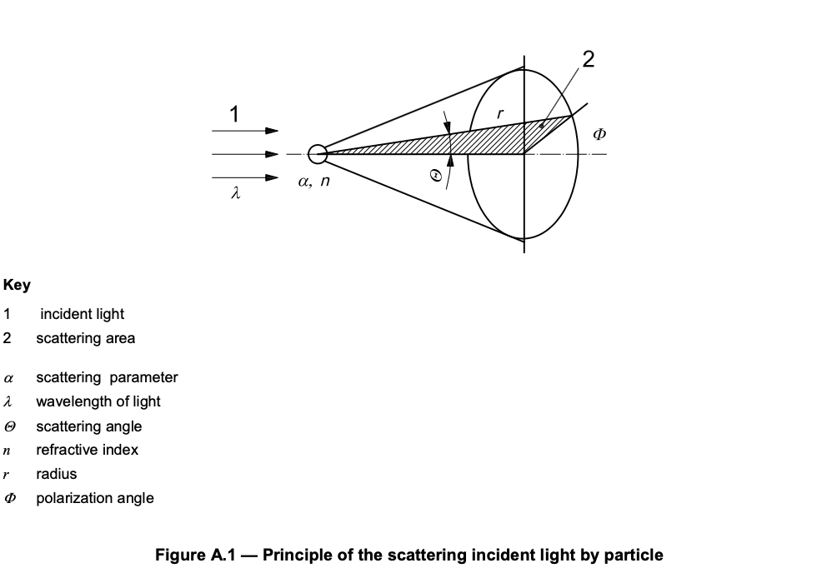
A.1.2 Theoretical response function
Although it is advisable to calibrate an optical instrument experimentally by means of test aerosols of known size and refractive index, theoretical response functions give a general indication of the characteristics of an optical system. By means of electromagnetic theory, the response function of optical systems, which describe the power of light scattered through the collecting aperture, can be calculated as a function of the diameter of a spherical particle. The parameter of these functions is the refractive index of the particle material. Commercial optical systems can be divided roughly into instruments using low-angle scattering, those collecting scattered light in the forward direction (diffraction lobe) and those employing right-angle scattering. With respect to the light source, one has to distinguish between polychromatic incandescent light and monochromatic laser light.
The influence of monochromatic and polychromatic light on the response function is demonstrated in FigureA.2, where the partial scattering cross-section is plotted against the particle diameter for monochromatic and white light and a mean scattering angle of Θ = 45°. For monochromatic light, the curves show typical oscillations. These fluctuations can be smoothed by using either white light and a mean scattering angle between 45° and 90°, or monochromatic light and a wide angle collecting aperture. In the diameter range smaller than the wavelength, the response functions are monotonic even for monochromatic light.

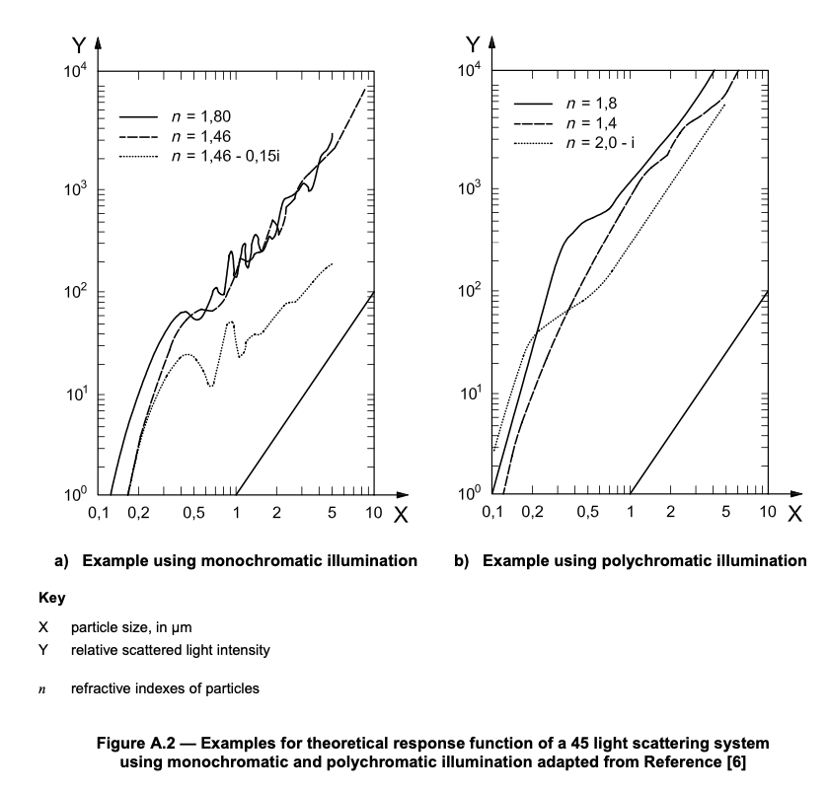
A.2 Operating principle
The operational principle of an LSAS [5] is based on the particle passing individually through a light beam (Figure A.3) or through an intensively lighted measuring volume (Figure A.6) and on collecting the light scattered by the particles. At the same time, the intensity of the scattered light is interpreted as a measure of the particle size. From the number of the counted scattered light impulses, one can conclude with known sample volume flow and defined measuring period the particle number concentration. Figure A.3 shows the set-up in principle. Laser diodes, He-Ne lasers or intensive white sources of light (e.g. xenon high-pressure lamps) are used. The scattered light is collected by optics under a certain solid angle (receiver aperture) and focussed onto a detector (photo-multiplier or photodiode).
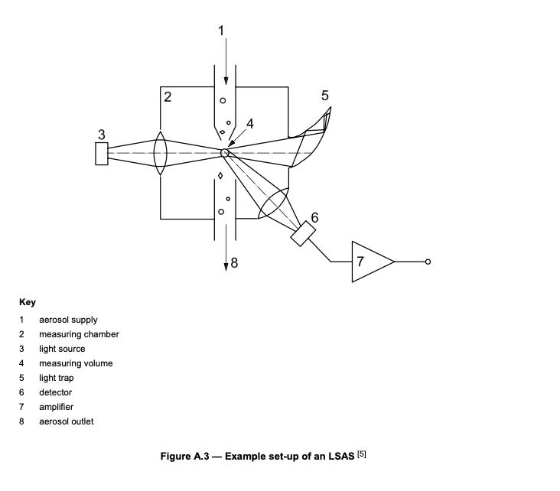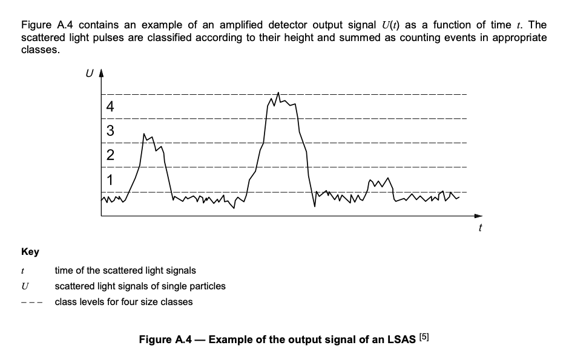

A.3 Definition of the sensing zone
Figures A.5 and A.6 illustrate how the sensing zone can be defined to determine where the scattered light is collected by the photo-detector. Where the sensing zone is aerodynamically defined, the sample volume flow rate is equal to the effective detection flow rate, but where the sensing zone is optically defined, then the effective detection flow rate is smaller than the sample volume flow rate.
Optically defined measuring volumes can be made very small and therefore are useful for the measurement of particle size distributions at high particle number concentrations with as little coincidence error as possible. A particle number concentration of 1012 particles/m3 can be shown by a simple calculation to be equivalent to a single particle in the volume enclosed by a cube with an edge length of 100 μm. Thus, should a particle number concentration of 1011 particles/m3 need to be measured, the edge length of the measuring volume cannot be larger than 100 μm for measurements to be free from coincidence error. The indication of the measuring volume size is very helpful for the user in order to estimate the maximum particle number concentration that can be measured without coincidence errors.
In Figure A.6, the problem of the border zone error can be seen. A particle which is partially illuminated in the border zone scatters only a fraction of the light of a particle of the same size which is situated in the measuring volume centre. The border zone error becomes larger with increasing particle size.

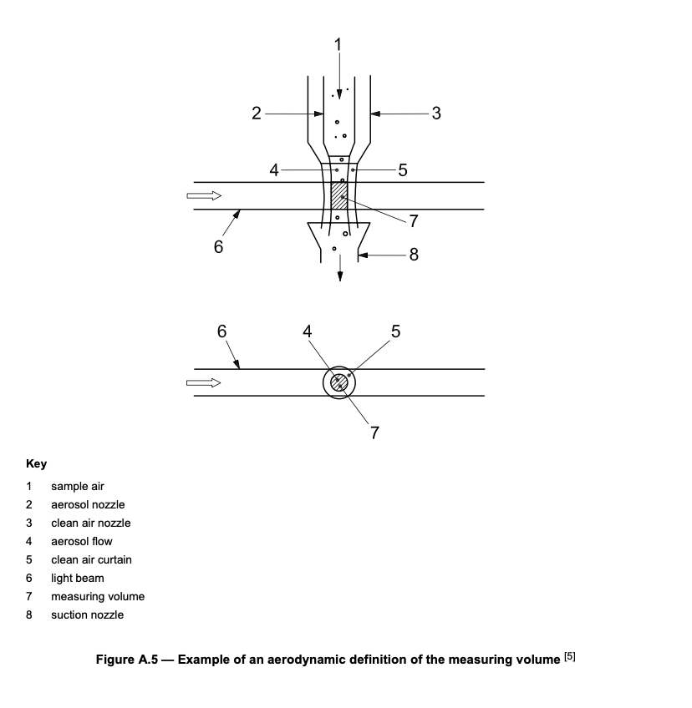

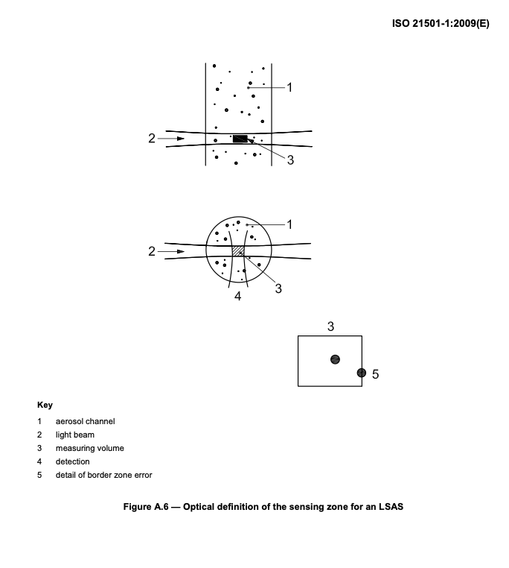

Annex B
(informative)
Particle size standards
B.1 Particle size reference materials
The unambiguous realization of particle size in terms of the SI-unit length is possible only with microscopic methods and for spherical particles. Nevertheless, laboratories using LSAS also have needs for metrological quality assurance, which can be met, for example, by reference materials. For the generation of reference aerosols for the test and calibration of measuring instruments, two different approaches can in principle be taken.
On the one hand, spherical, monodisperse reference particles are commercially available in defined sizes as bulk or as aqueous suspensions. The size of the particles can be examined, for example, by light or electron microscopically and is usually certified by the manufacturer. These particles can be regarded as certified reference materials.
Alternatively, monodisperse reference particles can be generated directly in the aerosol phase. These test aerosols are generated in situ for immediate use and the users must satisfy themselves as to the reliability of the methods used.
B.2 Certified reference materials for dispersion with aerosol generators
The currently available reference particles are very limited in terms of particle composition. There are monodisperse polymer latex particles which are available as suspensions or in bulk.
In order to be able to be used for calibration purposes, the particles must be aerosolized. The user must both achieve and demonstrate a complete and reproducible dispersion. Otherwise, incompletely dispersed particle agglomerates can result in erroneous calibration results.
In addition, aerosolization can introduce an electrostatic charge on to the particles. The influence of this charge on the calibration experiment must be determined. If necessary, the calibration aerosol must be electrostatically equilibrated using suitable methods.
Bulk particles can be dispersed using a solid aerosol generator such as a brush feeder [4], a small-scale Venturi feeder or a belt feeder [4], as relatively small quantities are required. These methods are limited to particle sizes > 0,5 μm, since for smaller particles incomplete deagglomeration is achieved.
Polymer latex suspensions usually contain about 10 % solids. After sufficient dilution, they are nebulized, e.g. with the help of a nozzle nebulizer [4]. The dillution factor must be suitably large to ensure that there is no more than one latex particle in each water droplet generated during nebulization. Consequently, this means that the vast majority of the droplets do not contain latex particles. Furthermore, after evaporation of the water, these droplets result in residual particles from the impurities in the water and from the stabilizer substances added to the latex suspension. The particle number concentration of test aerosols generated in such a way is therefore limited to a few hundred particles per cubic centimetre, while the particle number concentration of the smaller residual particles can amount to as many as 10 /cm . Such test aerosols are therefore not suitable for testing instruments which do not measure particle size, as such instruments will be unable to distinguish between the latex and residual particles.
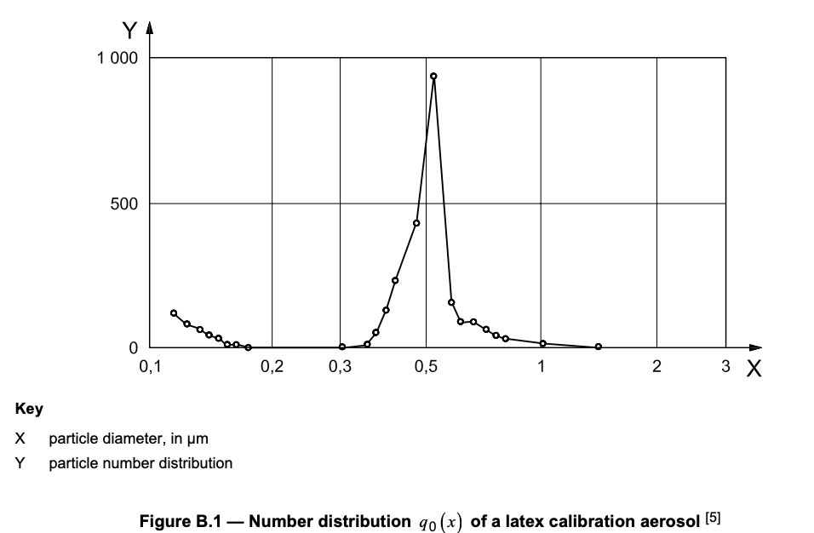
In Figure B.1, the number distribution of a latex calibration aerosol measured with an LSAS is represented. One recognizes a narrow, almost monodisperse peak in the distribution slightly above 0,5 μm. The larger particles existing in small numbers are agglomerates from droplets, which contained more than one latex particle. The distribution of the residual particles begins only below 0,2 μm and is shown by this measurement to be a comparatively small part of the distribution.
B.3 Generation of test aerosols from materials other than reference materials
The generation of monodisperse test aerosols with a vibrating orifice generator [4] belongs to the secondary particle size standards. At this instrument, a periodic instability is superimposed onto a liquid jet by a vibrating orifice, which under certain operating conditions leads to the break-up of the jet into equally sized large drops. The size of these drops is determined by the volume flow of the liquid through the orifice and the vibrating frequency of the orifice. By dissolving the aerosol substance in a volatile solvent, the diameter of the ultimately generated particles, after subsequent evaporation of the solvent from the generated droplets, can be adjusted within broad limits by varying the concentration of the desired material in the solvent. Usable aerosol substances are, for example, heavy-volatile hydrocarbons which can be dissolved in alcohols or salts in aqueous solution. Particles can be generated within a size range of approximately 1 μm to 50 μm, with the particle number concentration of the order of 100 particles/cm3. Since each vibration of the orifice generates a single droplet, the instrument could in theory be a source of a standard particle number concentration. However, undefined losses of the generated particles in the transport system make this difficult in practice.
Monodisperse aerosols can also be generated by classifying polydisperse aerosols. For fine and superfine particles, differential mobility analysers are used for this purpose. With these devices — within the particle size range of between approximately 5 nm and 1 μm — a fraction of particles having the same electrical mobility can be extracted from a polydisperse aerosol. If the number distribution of the polydisperse aerosol is not too broad and its median diameter is selected accordingly, all extracted particles carry only a single electrical charge and the monomobile aerosol is also monodisperse. The particle number concentration of the monodisperse aerosol fraction depends on the particle size distribution of the polydisperse aerosol and the size selected for the classified particles. This particle number concentration range is typically in the range of 100 to 100 000 particles/cm3.
Differential mobility-analysers can also be used to separate latex test aerosols generated from suspensions from the residual particles. Since only some of the latex particles delivered to the mobility analyser carry a single electrical charge, the particle number concentration of the classified aerosol is significantly smaller than that of the aerosol before classification.

Annex C
(informative)
Effects of the LSAS parameters on the particle size and particle number concentration determination
C.1 Calibration curve
A monotonic, steadily increasing calibration curve is important for high size resolution and classification accuracy.
Due to the influence of optical properties of the particle material, particle shape (spherical or irregular) and the optical set-up (light source, detection angle), experimentally measured calibration curves may differ from theoretical predictions.
It is advisable to calibrate an optical instrument experimentally by means of test aerosols of known size and refractive index. The output of such a calibrated instrument will then be related to light scattering equivalent particle diameter.
A steadily increasing calibration curve can be achieved by using white light and a 90° scattered light detection, or by collecting the scattered light over a large angle range.
C.2 Border zone error
Border zone error results in undersized particles. Border zone error increases with increasing particle size.
C.3 Coincidence error
Coincidence error results in the underestimation of particle number concentration and the overestimation of particle diameter, as described in Reference [9].
C.4 Size resolution
Size resolution is a measure of the ability of an instrument to distinguish between particles of different sizes. With low size resolution, neither the mean nor the modal diameter of a particle distribution can be determined reliably.
C.5 Sizing accuracy
Poor sizing accuracy results in the mean and/or the modal diameter of a particle size distribution being determined incorrectly.
C.6 Counting efficiency
Counting efficiency directly affects the measurement of particle number concentration and consequently of the reported particle size distribution.
C.7 Effective detection flow rate
The tolerances and/or the variations of the effective detection flow rate directly affect the determination of particle number concentration.

Annex D
(informative)
Representative sampling
D.1 Transport losses in sampling tubing
All aerosol measurements involve collecting a sample of the gas-borne particles, transporting this sample to a measuring device, and efficiently detecting the particles within the device. The importance of this measurement chain is frequently overlooked, which leads to error in the measurement and underestimation of the measurement uncertainty.
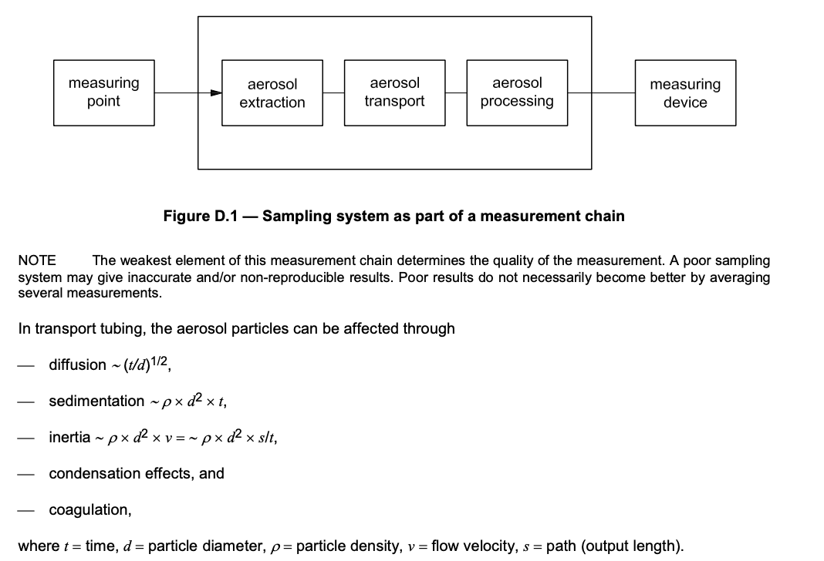
Coagulation is the collision and adhesion of particles. With coagulation, the particle diameter becomes larger and the particle number concentration becomes smaller with constant mass concentration. Gas conditions: temperature T = 20 °C, pressure P = 1 013 hPa, particle density ρ = 1000 kg/m3.
The coagulation half-life t1/2 is the period in which the particle number concentration is reduced by half due to coagulation effects.
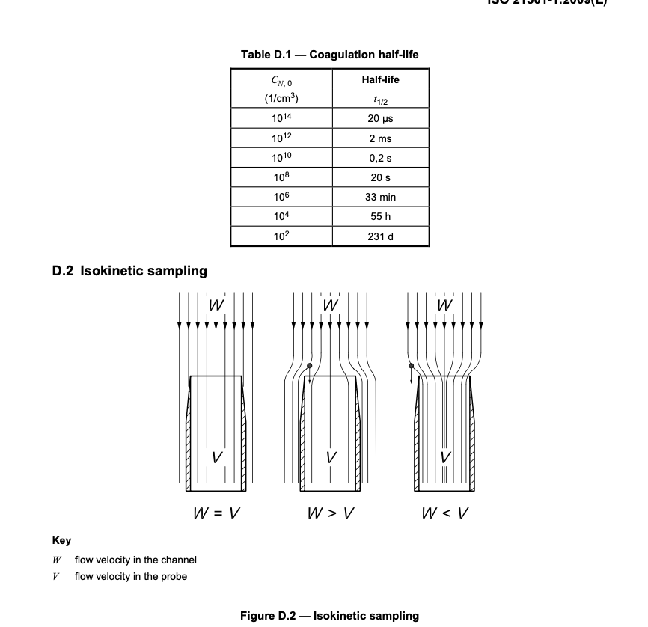
In the isokinetic case (W = V), all particles in the probe cross-section enter the sampling probe and are collected.
If the sample flow is too slow (W > V), comparatively more large particles enter the sampling probe, as they cannot follow the diverging flow lines due to their inertia.
If the sample flow is too fast (W < V), comparatively more small particles enter the sampling probe, because larger particles cannot follow the converging flow lines due to their inertia, and they pass by the sampling probe.
When using two particle counters or two sampling probes for comparative measurements, the isokinetic sampling error must be similar for both.

Annex E
(informative)
Example of an LSAS calibration with DEMS-classified PSL particles
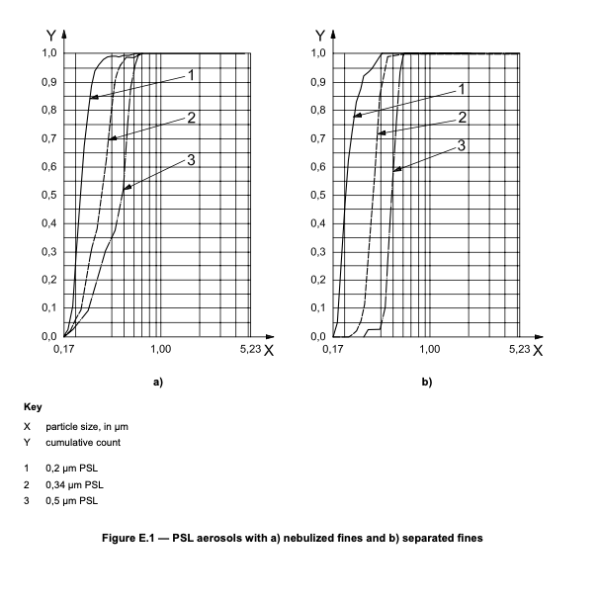
In Figure E.1 a) and b), the measured size distributions of three different polystyrene latex (PSL) aerosols are reported. The PSL suspensions (0,2 μm; 0,34 μm; 0,5 μm) were aerosolized in each case in a separate generator and were supplied directly to an LSAS as shown in Figure E.2 a). It can be clearly seen from the shape of the cumulative count in Figure E.1 a) that there are finer particles present in the aerosol in addition to the latex particles. As is known, the nebulization of PL suspensions does not generate an exclusive monodisperse latex aerosol, since the stabilizers in the suspension are also nebulized and measured (see Figure B.1). This provides an explanation for the fine particles seen in Figure E.1 a). However, it is also possible that the fine particles represented in the curve could be due to a residual border zone error of the measuring system.
In a separate test, the three different latex aerosols were classified through a Differential Electrical Mobility Spectrometer (DEMS) before being measured with the LSAS [Figure E.2 b)]. The results are reported in Figure E.1 b). It can be clearly seen that the LSAS did not measure any fine particles in this case. Therefore, the fine particles were residue from the latex suspension which were removed from the distribution by the DEMS and the LSAS correctly measured the latex aerosol, which was contaminated with fine particles, as reported in Figure E.1 a).
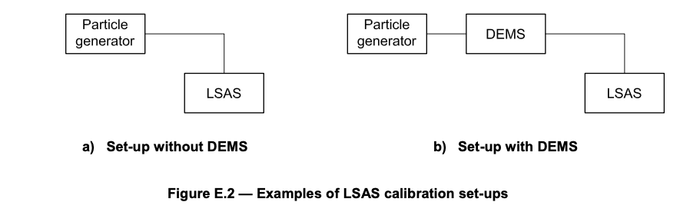
The slope of the cumulative curve is a measure for the particle size resolution of an LSAS.
The position of the cumulative curve at the value 0,5 on the ordinate provides information on the sizing accuracy of the LSAS.
The larger the border zone error, the poorer the particle size resolution and the sizing accuracy.

Bibliography
[1] ISO 2395:1990, Test sieves and test sieving — Vocabulary
[2] ISO 4225:1994, Air quality — General aspects — Vocabulary
[3] ISO 9276-1, Representation of results of particle size analysis — Part 1: Graphical representation
[4] VDI 3491 parts 1-16, Particulate matter measurement
[5] VDI 3867 parts 1-5, Measurement of particulate matter in ambient air — Methods for characterising test aerosols
[6] Aerosol Measurement — Principles, Techniques and Applications, 2nd ed., Chapters 15 and 16 (ed. Baron, P.A. and Willeke, K.), John Wiley and Sons, Inc., New York, 2001
[7] BACH, B. and SCHMIDT, E. Influence of leaks in surface filters on particle emissions/ Einfluss von Fehlstellen in Oberflächenfiltern auf die Partikelemissionen. Gefahrstoffe — Reinhaltung der Luft, 65(4), 2005
[8] BINNIG, J., MEYER, J. and KASPER, G. Integration of cyclones and an optical particle counter into a filter tester VDI-3926/Type1 to characterize PM2.5 emissions from pulse-jet cleaned filter media. Gefahrstoffe - Reinhaltung der Luft, 65(4), 2005
[9] BITTERMANN, H., SEITZ, M., MÖLTER, L. and SCHMIDT, M. Determining Fractional Efficiency in CAFs. Filtration & Separation, 43(10), December 2006, pp. 18-21
[10] BOTTINGER, M. and UMHAUER, H. Single Particle Light Scattering Size Analysis: Quantification and Elimination of the Effect of Particle Shape and Structure. Particle & Particle Systems Characterization, 6, 1989
[11] FRIEHMELT, R., BÜTTNER, H. and EBERT, F. On-line Measurement of Particle Sizes and Number Concentrations: Establishment of a Combined Measuring System. Partec 98, Nürnberg, Germany, 10-12 March 1998
[12] GEBHART, J. Performance and properties of optical particle counters. Technisches Messen, 56, 1989, pp. 192-203
[13] GEBHARDT, J. and ANSELM, A. Effect of Particle Shape on the Response of Single Particle Optical Counters. In: Optical Particle Sizing: Theory and Practice (ed. Gouesbet, G. and Gréhan, G.), New York, 1988
[14] HELSPER, C. Determination, simulation and correction of the non-ideally transient characteristic of classifying aerosol measuring procedures. Dissertation, University Duisburg, Germany, 1981
[15] HEMMER, G., UMHAUER, H., KASPER, G. and BERBNER, S. The Separation Efficiency of Ceramic Barrier Filters Determined at High Temperatures by Optical Particle Size and Concentration Measurement. In: High Temperature Gas Cleaning Vol. II, (ed. Dittler, A., Hemmer, G. and Kasper, G.), Karlsruhe, 1999
[16] HESS,W.F. and MATSCHKE,C. Comparison of two scattered light particle counters in practical application in a dust removal test stand. F & S International Edition, No. 5, May 2005
[17] HINDS, W.C. Aerosol Technology — Properties, Behaviour and Measurement of Airborne Particles, 2nd edition, Chapter 16. Wiley-Interscience Publication, New York, 1999
[18] KANAOKA, C., KISHIMA, T. and FURUUCHI, M. Accumulation and release of dust from rigid ceramic filter element. In: High Temperature Gas Cleaning (ed. Schmidt, E., Gäng, P., Pilz, T. and Dittler, A.), Institut für Mechanische Verfahrenstechnik und Mechanik, Karlsruhe, 1996
[19] LINDENTHAL, G. and MÖLTER, L. New White-Light Single-Particle Counter — Border Zone Error nearly Eliminated. Partec 98, Nürnberg, Germany, 10-12 March 1998
[20] MAUS, R. and UMHAUER, H. Determination of the Fractional Efficiencies of Fibrous Filter Media by Optical In Situ Measurements. Aerosol Science and Technology, 24, 1996
[21] MÖLTER, L. In-Situ Particle Size Analysis at High Concentrations. Partec 1995, Nürnberg, Germany, 21-23 March 1995
[22] MÖLTER,L. and LINDENTHAL,G. How to Measure the Fractional Grade Efficiency Correctly for ISO 9000. Filtration & Separation, 32(8), September 1995, pp. 751, 753, 755, 757, 759
[23] MÖLTER, L., SCHMIDT, M. and SCHÜTZ, S. Minimum demands on a “reference” filter test stand for air and gas filtration. F & S International Edition, No. 3, 2003
[24] MÖLTER, L. and SCHÜTZ, S. Accurate Particle Counting of Vacuum Cleaner Emissions. Filtration & Separation, 40(9), November 2003, pp. 28-31
[25] MORWEISER, M. and BOHNET, M. Influence of Temperature and Pressure on Separation Efficiency and Pressure Drop of Aerocyclones. In: High Temperature Gas Cleaning (ed. Schmidt, E., Gäng, P., Pilz, T. and Dittler, A.), Institut für Mechanische Verfahrenstechnik und Mechanik, Karlsruhe, 1996
[26] MÜHLENWEG, H. Development of a Scattered Light Measuring Method for the Particle Size Analysis in Gas Flows. Dissertation Technical University of Clausthal, Germany. Verfahrenstechnik, Shaker Verlag, Aachen, Germany, 1996
[27] PETERS, C., GEBHARDT, J., ROTH, C. and SEHRT, S. Test of high sensitive laser particle counters with PSL-Aerosols and CNC reference. Journal of Aerosol Science, 22, Suppl. 1, 1991
[28] RAASCH, J. and UMHAUER, H. Errors in the Determination of Particle Size Distributions caused by Coincidence in Optical Particle Counters. Particle & Particle Systems Characterization, 1, 1984
[29] SZYMANSKI, W.W. Applicability of Optical Particle Counters for Determination of Filter Efficiencies. International Symposium Filtration and Separation of Fine Dust, 24-26 April 1996, Proceedings, (ed. Höflinger, W.), Vienna, 1996
[30] UMHAUER, H. and BERBNER, S. Optical In-Situ Size Analysis of Particles Dispersed in Gases at Temperatures of up to 1 000 °C. Partec 1995, Nürnberg, Germany, 21-23 March 1995
[31] UMHAUER, H. and BOTTLINGER, M. Effect of particle shape and structure on the results of single-particle light scattering size analysis. Applied Optics, 30(33), November 1991

